Understanding DDoS Attacks and the Role of LOIC and Snort

In today's interconnected world, cybersecurity has become a critical concern. One of the most common cyber threats is a Distributed Denial of Service (DDoS) attack. This type of attack can disrupt online services, websites, and networks by overwhelming them with a flood of traffic. In this article, we will explore the concept of DDoS attacks and discuss two important tools used in their detection and prevention: LOIC (Low Orbit Ion Cannon) and Snort.

What is a DDoS Attack?

A DDoS attack occurs when multiple compromised devices, often referred to as a botnet, flood a target system with an overwhelming amount of traffic or requests. The goal is to exhaust the system's resources, such as bandwidth, processing power, or memory, rendering it unable to respond to legitimate user requests. DDoS attacks can target various types of systems, including websites, servers, or entire networks.



The Working of LOIC:

LOIC, or Low Orbit Ion Cannon, is a popular open-source network stress testing tool that can be misused for conducting DDoS attacks. It was originally developed as a legitimate tool for network administrators to test the robustness of their systems. However, due to its availability, it has been exploited by malicious actors.

LOIC works by allowing users to join a voluntary botnet. Once connected, the botmaster can control and coordinate the attack, directing all the participating devices to send a massive amount of traffic to the target. LOIC primarily uses the HTTP, UDP, or TCP protocols to flood the target's network with requests, overloading its capacity to respond.

Making a local host using XAMPP because we shouldn’t exploit LOIC

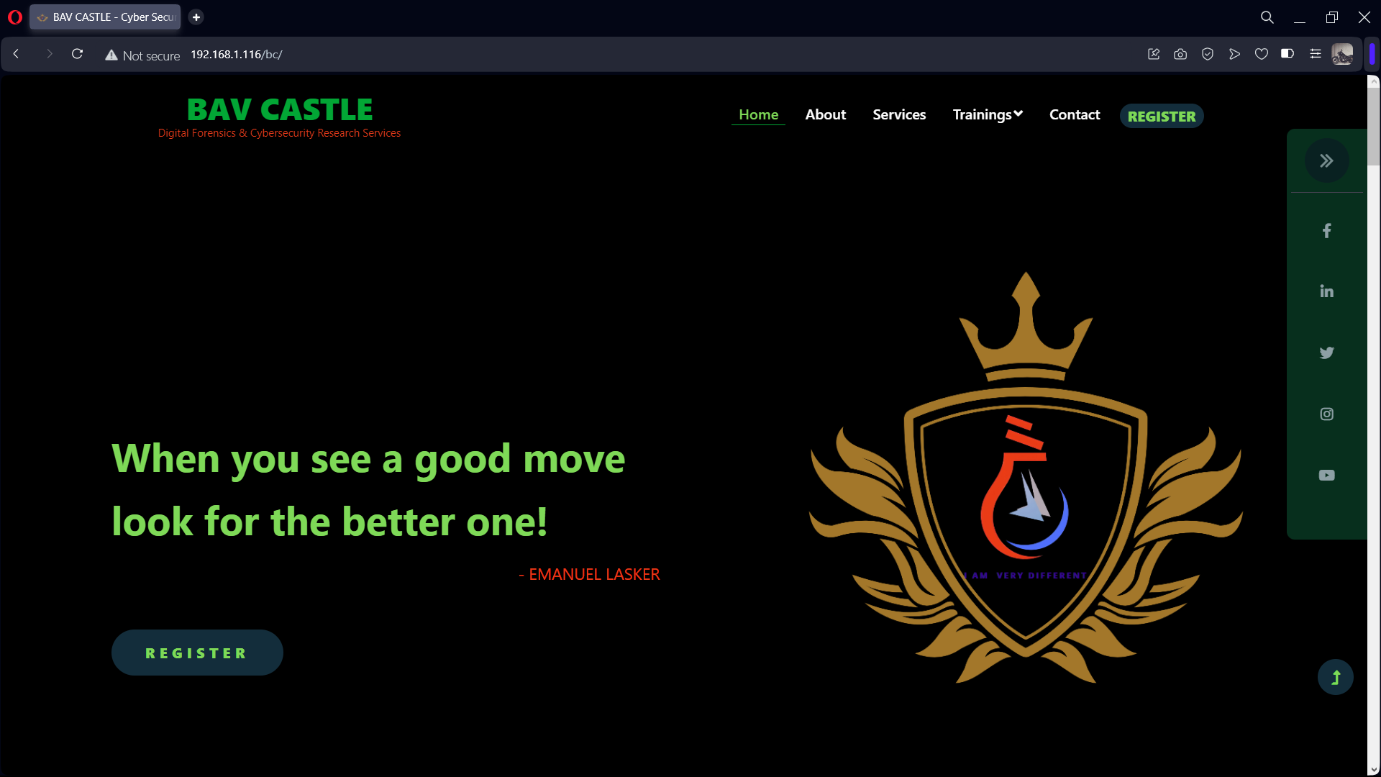

Launching LOIC

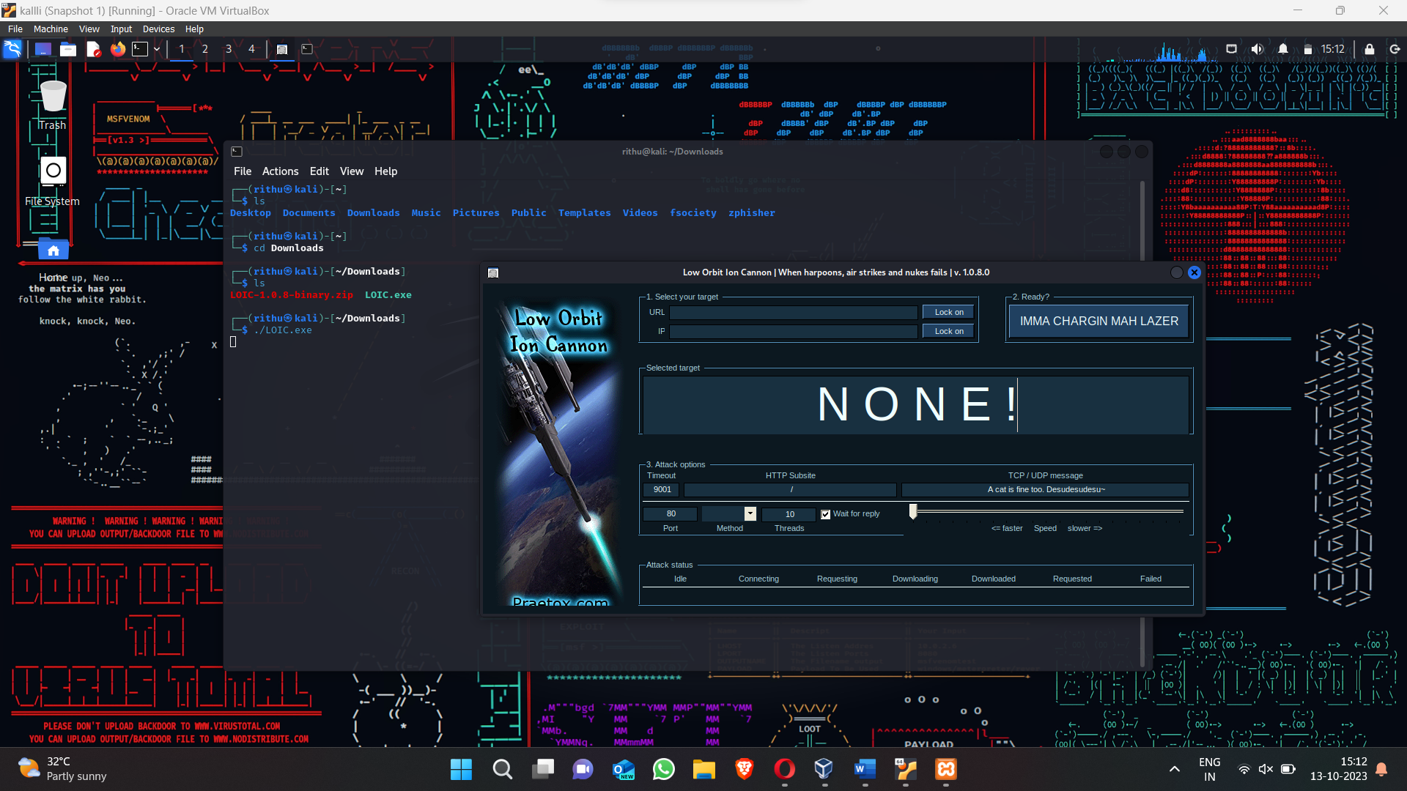

Locking on to the URL of the website and selecting method

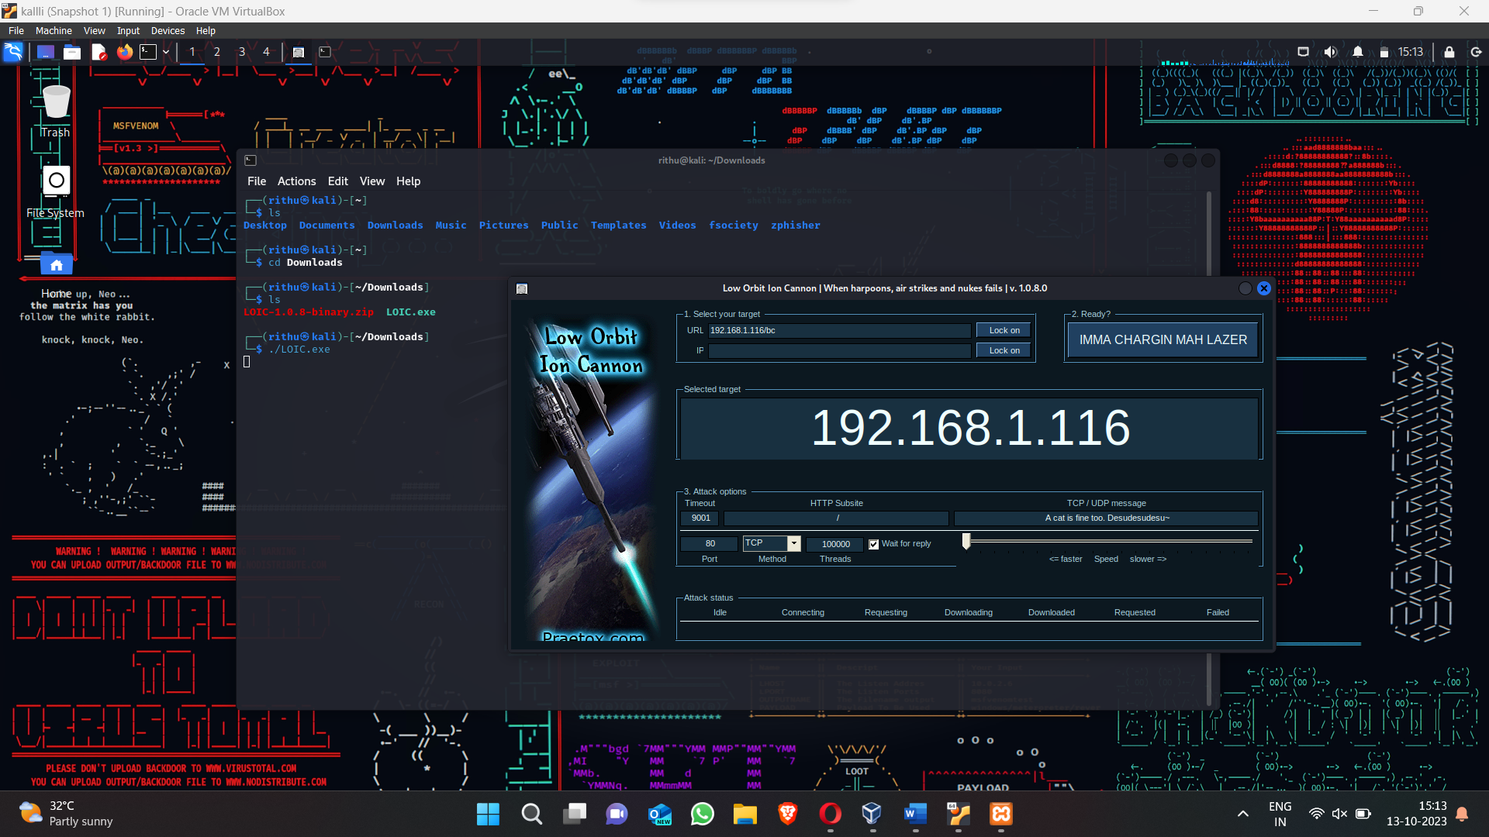

Give a lot of threads to increase the network traffic

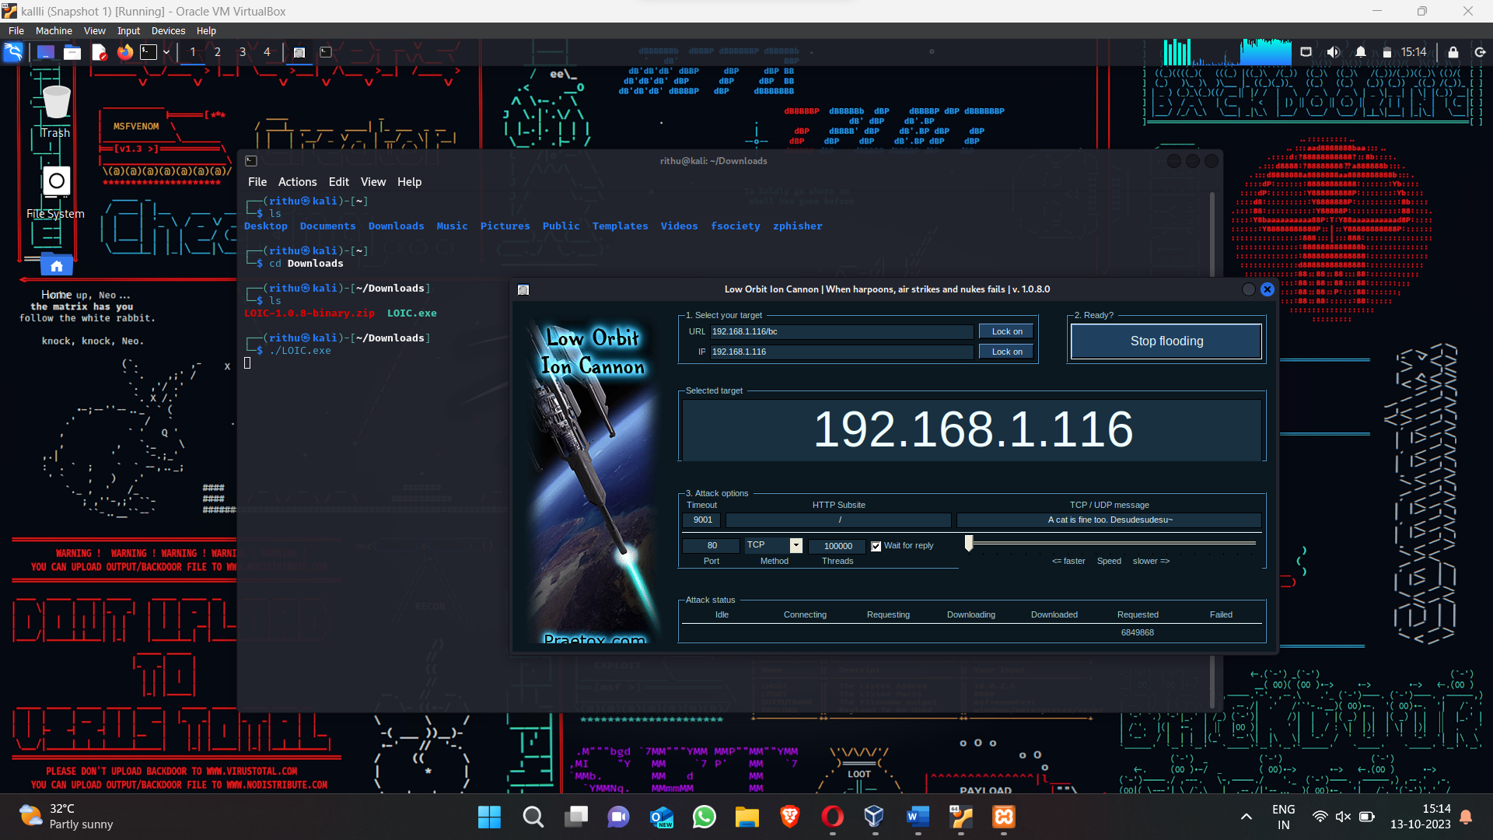

The Working of Snort:

Snort is an open-source network intrusion detection and prevention system (IDS/IPS). It is widely used to monitor network traffic and detect various types of cyber threats, including DDoS attacks. Snort operates by analyzing network packets in real-time and comparing them against a set of predefined rules or signatures. These rules define specific patterns or behaviors associated with known attacks.

To detect DDoS attacks, Snort looks for indicators such as an abnormally high number of incoming connections or traffic originating from a specific set of IP addresses. When Snort identifies suspicious activity, it generates an alert or takes preventive actions, such as blocking or diverting traffic from the attacking source.

Snort Detecting DDoS Attacks:

Snort can be configured to detect DDoS attacks by creating custom rules or using existing rules designed for this purpose. Some of the techniques Snort employs to detect DDoS attacks include: 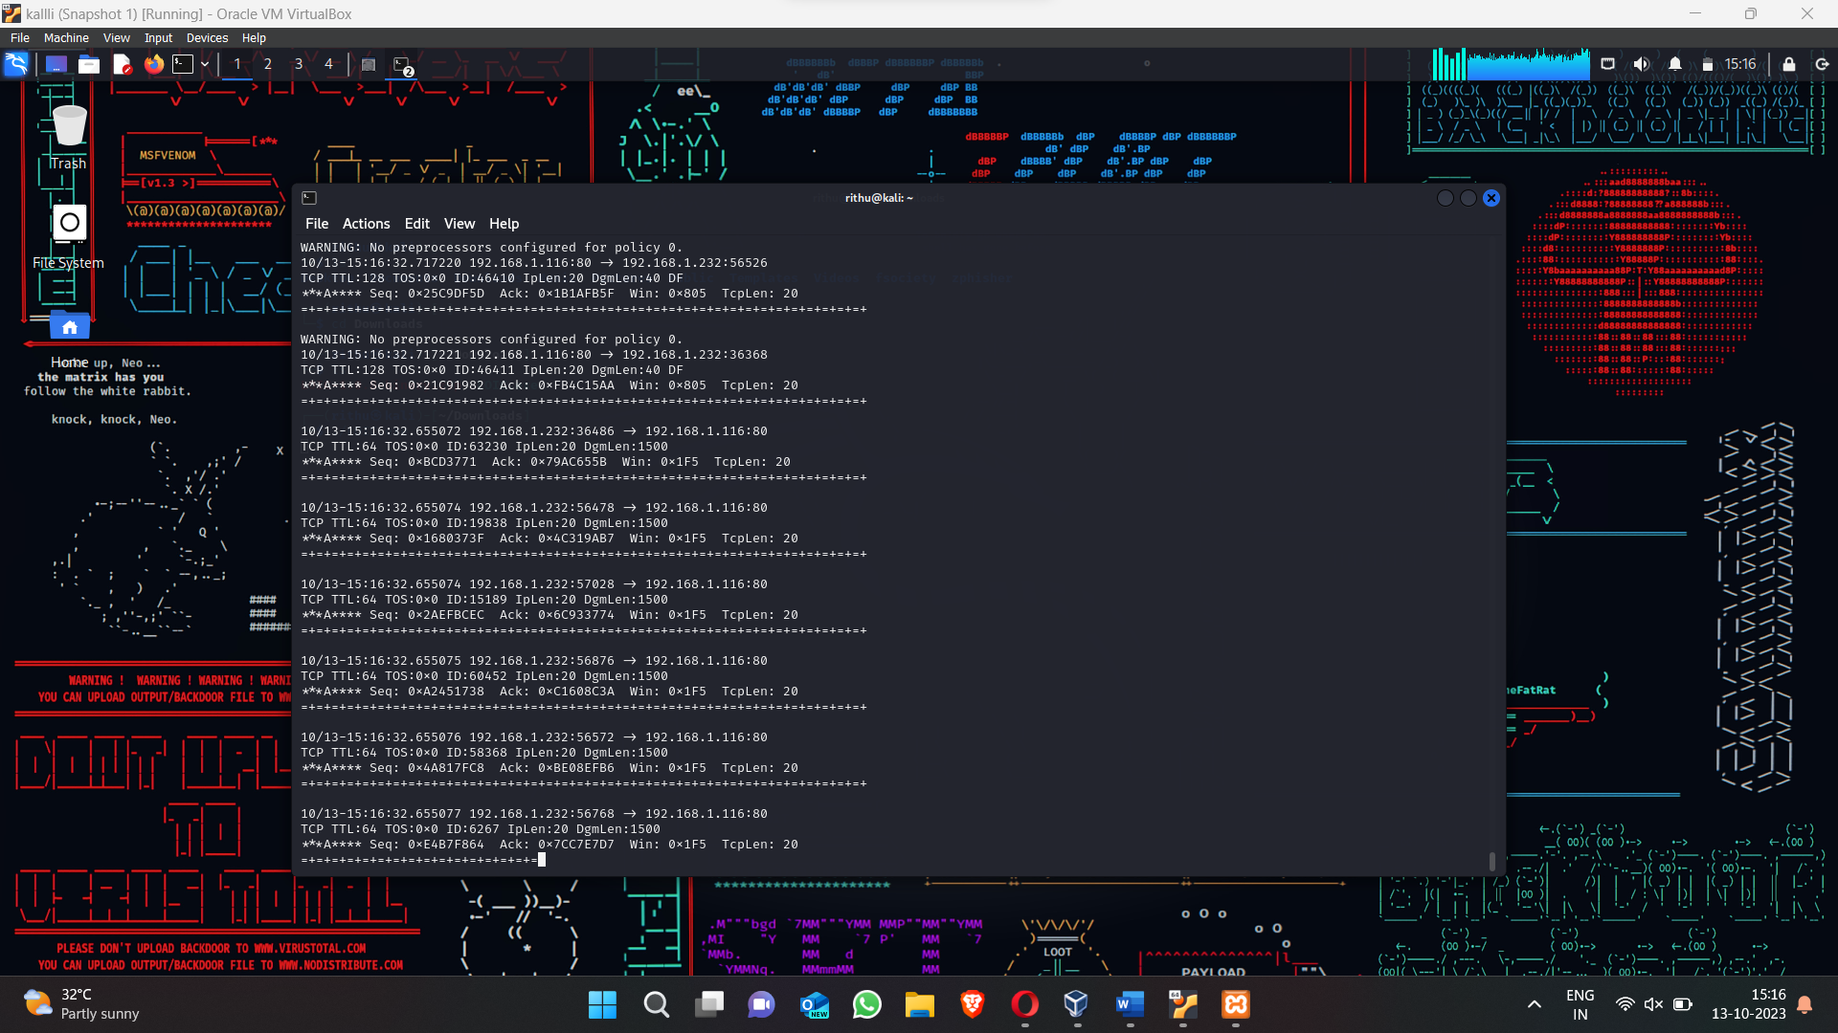

Threshold Monitoring: Snort can monitor network traffic and set thresholds for specific metrics like the number of connections, packets, or requests within a defined time frame. If the observed values exceed the thresholds, it generates an alert indicating a possible DDoS attack.

Anomaly Detection: Snort can use statistical analysis and machine learning algorithms to identify abnormal traffic patterns. It compares the current traffic behavior with a predetermined baseline and raises an alarm if significant deviations occur, indicating a potential DDoS attack.

Signature-based Detection: Snort maintains a vast database of attack signatures, including those associated with DDoS attacks. When network packets match these signatures, Snort generates an alert, enabling network administrators to respond promptly to the attack.

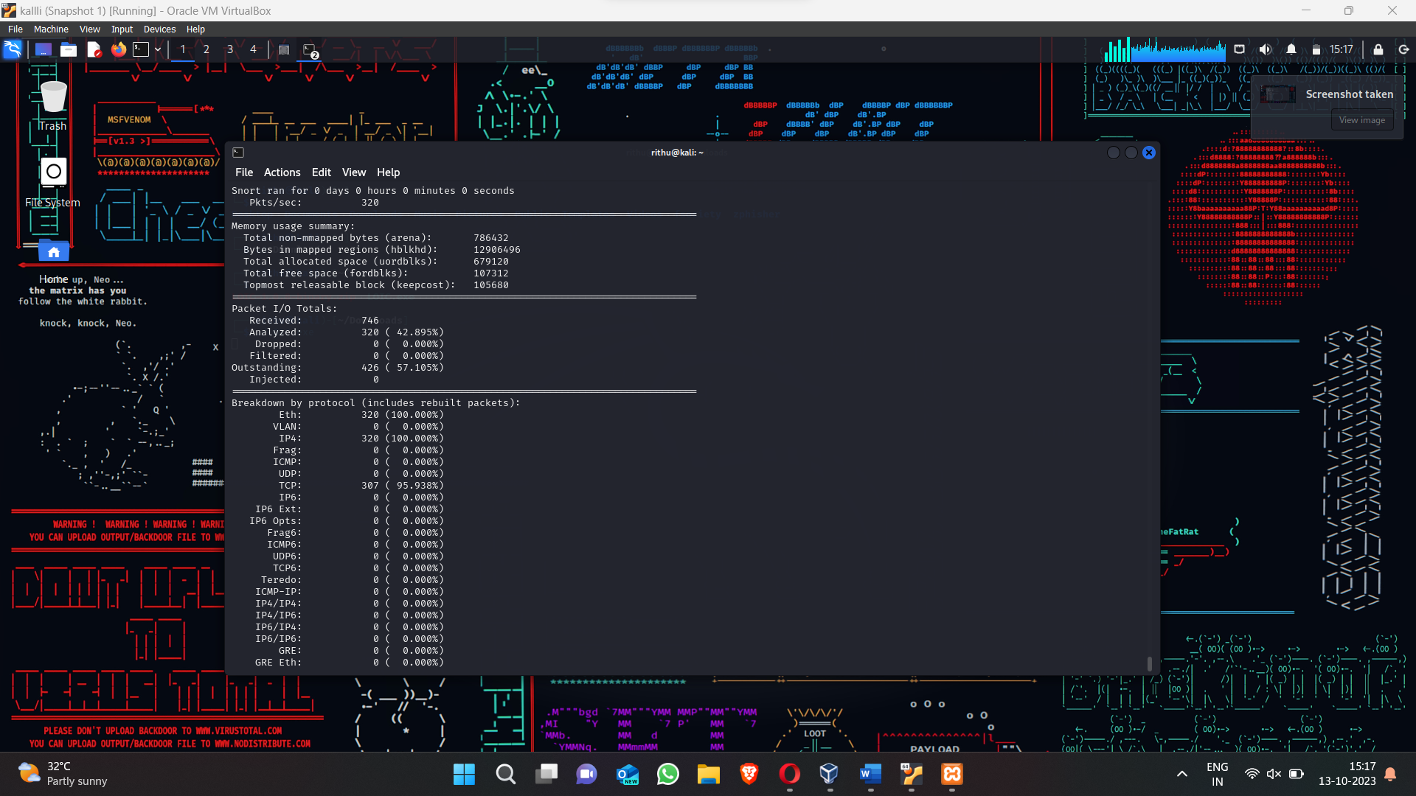

Rate Limiting: Snort can implement rate-limiting mechanisms to control the incoming traffic to mitigate the impact of DDoS attacks. By setting thresholds on various network parameters, Snort can limit the number of connections, packets, or requests from a single source, preventing it from overwhelming the system.

In conclusion, DDoS attacks pose a significant threat to online services and networks. Tools like LOIC can be misused to launch these attacks, while Snort plays a crucial role in detecting and mitigating such threats. By leveraging its detection capabilities and implementing preventive measures, organizations can protect their systems and maintain the availability and integrity of their services, even in the face of DDoS attacks.